# **טכנולוגיות אינטרנט מתקדמות - 61776 (WEB)**

**הגשת פרויקט**

**<Crypto Market Analysis Tool> <B3> <19>**

|  |  |
| --- | --- |
| **שם חבר.ת הצוות** | **תז** |
| Aharon Yonatayev | 203899786 |
| Ekateryna Petukhov | 323458349 |
| Hadi Danial | 208864751 |
| Niv Malka | 314730995 |

<Project Summary:

Our Crypto Market Analysis Tool is a comprehensive platform designed to empower investors with actionable insights and data-driven strategies for navigating the volatile cryptocurrency market. Through an intuitive interface and leveraging advanced technologies, our tool equips investors with the necessary tools to navigate the dynamic Bitcoin market landscape effectively.

Key Functionalities:

Bitcoin Graph Homepage: At the heart of our platform lies the Bitcoin Graph Homepage, providing users with real-time visualization of Bitcoin prices through interactive graphs. This intuitive interface allows users to track trends, patterns, and fluctuations in cryptocurrency prices over time, enabling informed decision-making.

Customizable Prediction Parameters: Our platform empowers users to tailor prediction parameters and timeframes according to their individual preferences and investment goals. By customizing prediction settings, users can refine their forecasts and make informed decisions aligned with their trading strategies.

Data Visualization Techniques: To enhance data interpretation and analysis, our tool supports a variety of visualization techniques including charts, graphs, and heatmaps. These visual representations provide users with intuitive insights into market trends, enabling them to identify opportunities and mitigate risks effectively.

Investor Wallets: The Investor Wallets feature offers users a comprehensive overview of their cryptocurrency transactions, including profit/loss calculations based on currency purchase date. Users can track the performance of up to three wallets, monitor their investment portfolio, and gain valuable insights into their trading activity.

User Registration and Personalization: Users can register for an account using their email, unlocking personalized features such as portfolio management and customized alerts. This seamless registration process enhances user engagement and enables a tailored trading experience.

Dark Mode Option: To accommodate varying preferences and reduce eye strain during extended usage, our platform offers a dark mode option. Users can seamlessly toggle between light and dark themes, enhancing usability and comfort.

About Page: The About page provides users with detailed information about our platform, including its purpose, features, and the technologies utilized in its development. Users can learn more about the team behind the project and our commitment to providing a secure and innovative trading experience.>

< Technologies Used:

Frontend: Our frontend is crafted using HTML, Tailwind CSS, React, and TypeScript, ensuring a modern and responsive user interface optimized for usability and performance.

Backend: We leverage Node.js and Express.js on the backend to deliver scalable and efficient server-side functionality, complemented by web crawlers for real-time data aggregation from diverse sources such as bitinfocharts.com and Yahoo Finance.

Database: MongoDB serves as our robust and flexible database solution, providing secure storage for user data, transaction history, and predictive analytics models..>

<<https://github.com/hadiDanial/Crypto-Market-Analysis-Tool>>

<<https://hadidanial.github.io/Crypto-Market-Analysis-Tool/frontend_react/build/>>

<<https://www.morethanwallet.com/app/343>>

**User Manual:**

**The website:** Use the navigation bar at the top to navigate to different features, including a bitcoin price chart and investor wallets.

**Bitcoin Price Chart:** Pick start and end dates, and see the history of bitcoin prices over the years.

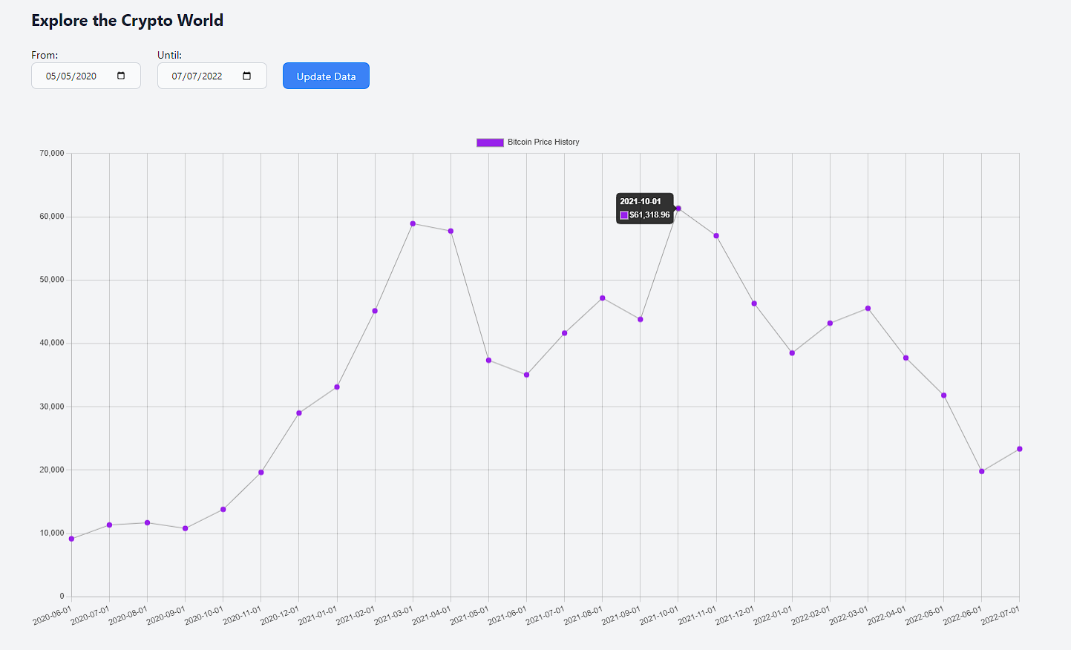

**Prediction:** A recommendation to the user on whether they should buy, sell, or hold their Bitcoin today based on our black box genetic algorithm



**Investor wallets:** Keep an eye on the biggest private wallets in the crypto world and see when they buy and sell their crypto currency so that you can make informed choices.

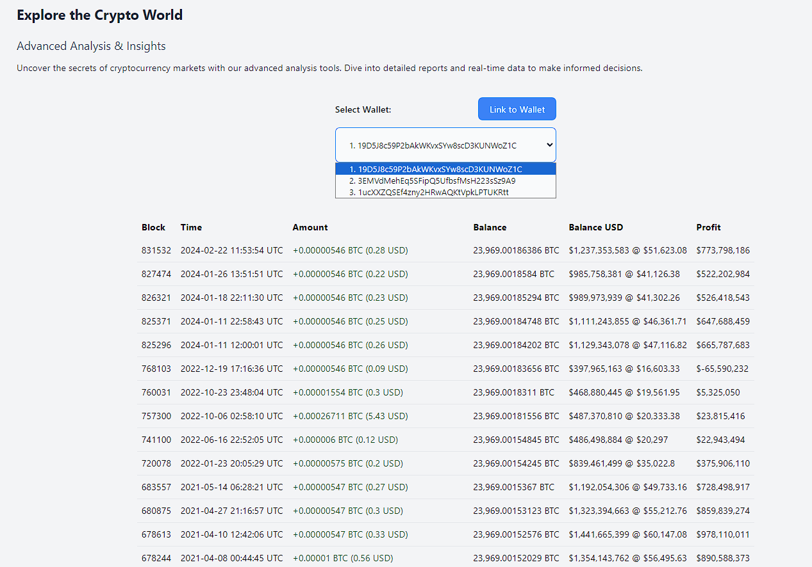

**Subscribe to our mailing list:** Subscribe to get notified about price changes and more interesting news in the world of crypto currencies! 

**Programmer Manual:**

**Frontend:**

The frontend is built with React, using TypeScript and Tailwind. The website is divided into different screens: Chart, Wallet and About, using React Router to navigate between the screens while sharing the same header and footer.

We used RTK Query to send API requests.

**Backend:**

The main functions in the backend are the functions that get real time data from certain websites, in the *crawl.ts* file:

crawlBitcoinWallets

Responsible for getting the wallet data of investors from bitinfocharts.com, using the Crawl library.

crawlBitcoinHistory

Responsible for getting real time data on Bitcoin Price History from Yahoo Finance.

**Database:**

We used a Mongo database in order to save user emails so that we could send them update emails.

**Hosting:**

The backend is hosted on Heroku, while the frontend is deployed to GitHub pages. The links can be found in the GitHub repository README file.